**Title**: A holistic approach of Comparative Analysis of Independent Component Analysis and Principal Component Analysis of Electromyographic Movement Detection using Machine Learning and Deep Neural Network

**System Work Flow:**

**About the Dataset**

**Deep Learning Architecture**

**Feature Selection**

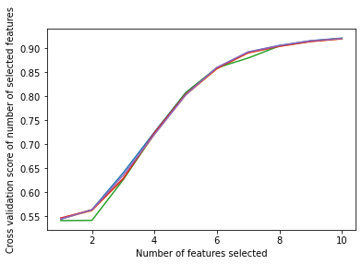

**Figure:** How Accuracy is Increasing by Selecting each Features (Wrapper Method: RFE Feature Selection)

|  |  |
| --- | --- |
| **Features** | **Boruta Feature Selection** |
| Emg 1 | True |
| Emg 2 | True |
| Emg 3 | True |
| Emg 4 | True |
| Emg 5 | True |
| Emg 6 | True |
| Emg 7 | True |
| Emg 8 | True |
| Emg 9 | True |
| Emg 10 | True |

**Table:** Optimal Number of Feature Selected by Boruta Feature Selection (Wrapper Method)